**Step 1. Enhance cat’s list with votes and ticks**

**Visuals**

* The application should display
  + a list of at least 5 cats, listed by name
  + an area to display the selected cat
* If the image of a cat was already viewed, you should display a tick sign ✓ next to the cat’s name.
* In the cat display area, the following should be displayed
  + the cat's name
  + a picture of the cat
  + vote spinner
* The user should not be able to see a flash of unbound interpolation.

**Interaction**

* The votes should increment or decrement depending on whether up or down arrow was clicked in the spinner.

**Inspiration**

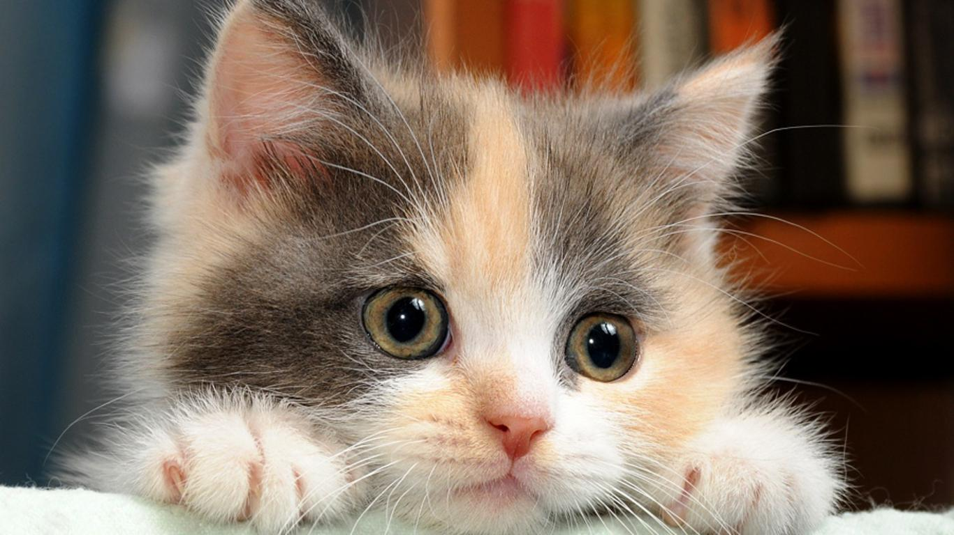

## Step 2. Add a search box and orderBy fields

### Visuals

* Add a search box to find cats by name with a button.
* Add a dropdown to choose order of the cats.

### Interaction

* The cats filtering should be applied after the button next to the search field is clicked.
* Ascending or descending order should be applied immediately after the selected value in orderBy dropdown is changed.

### Inspiration

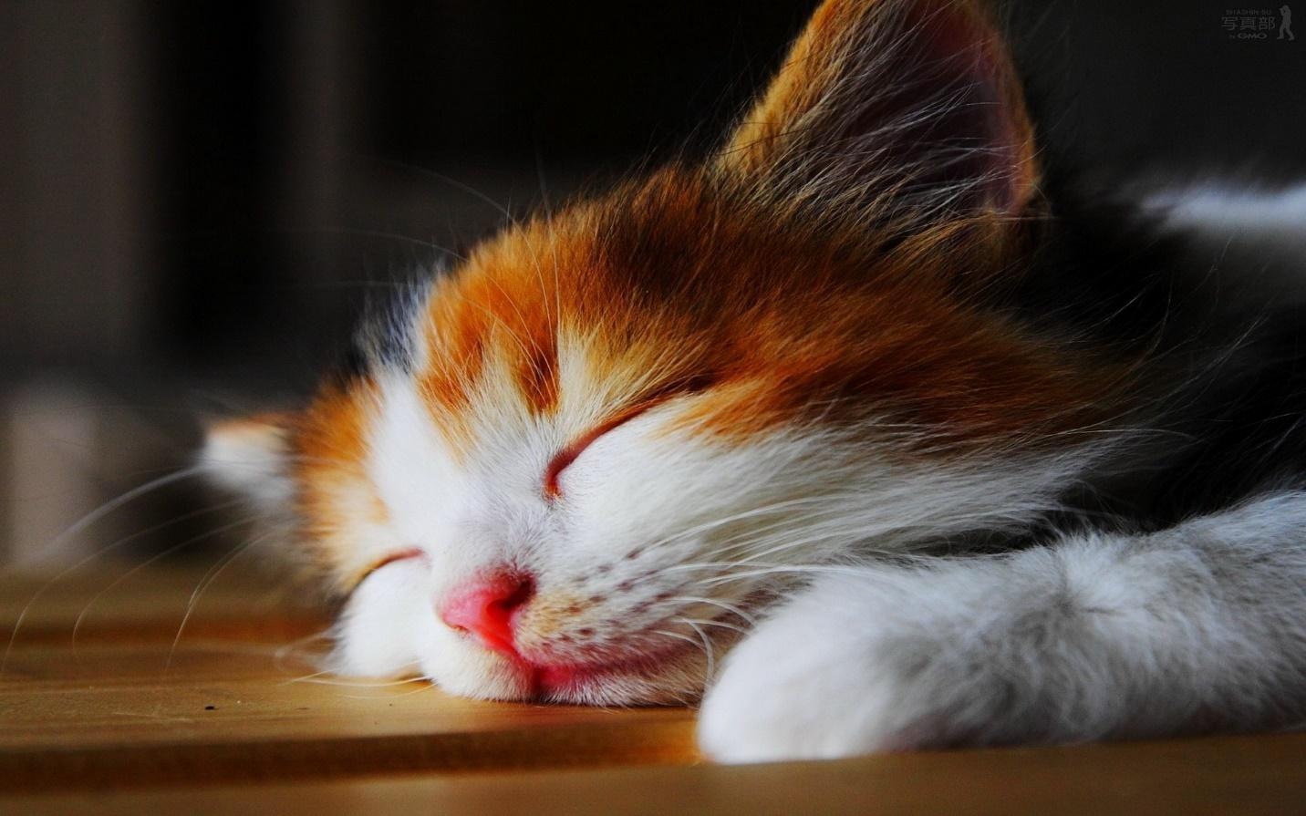

Step 3. Create a separate page to add a new cat

### Visuals

* The form should display input fields to modify the following:
  + the cat's name
  + an url of a cat’s picture
  + an image from the picture’s url
* Visual feedback about validity of the forms and corresponding error messages.
* The specifics of the layout do not matter, so style it however you'd like.

### Interaction

* The form should have 2 buttons to save or cancel editing (saving is allowed not to work for now).
* The form should contain validation rules: both fields are required, url should be a valid url. If some of the rules does not match, user won’t be able to click save button.
* The url change should be reflected in the model after blur.

### Inspiration

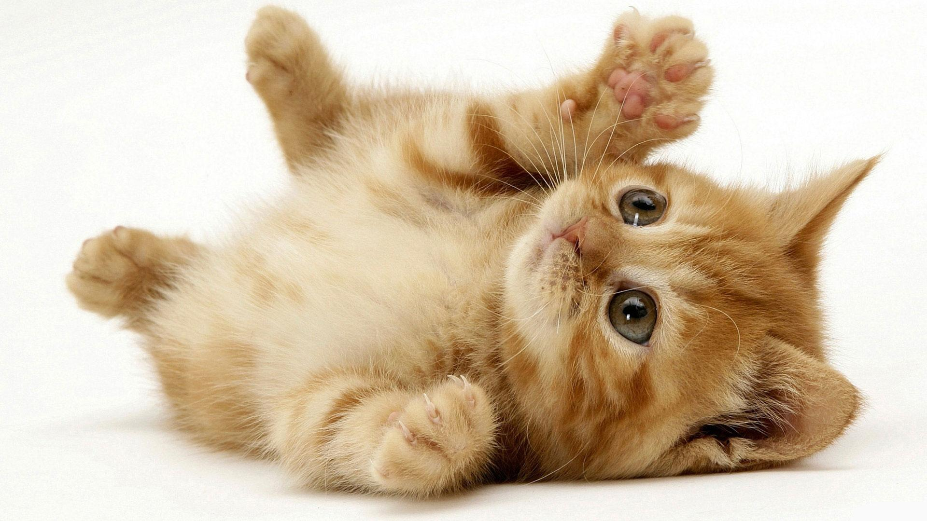

Step 4. Optional

**Visuals**

* Smile should be appear near count of votes.
* All dates in the application should be presented in format dd-mmm-yyyy
* Show information about cats that have positive votes at the top of the page.

### Interaction

* Add smile filter to describe positive and negative voting. If voting is more than 0 than smile is happy. If voting count is less than 0 than smile is sad. Otherwise, smile is neutral.
* Apply standard filter to any date information. Date information should be presented in format dd-mmm-yyyy.
* Information about cats that have positive votes should contain count of cat with positive votes and name of the first cat that received the positive vote. For example:

“No cat has positive vote”

“Tom and 2 more cats have positive votes”

### Inspiration

